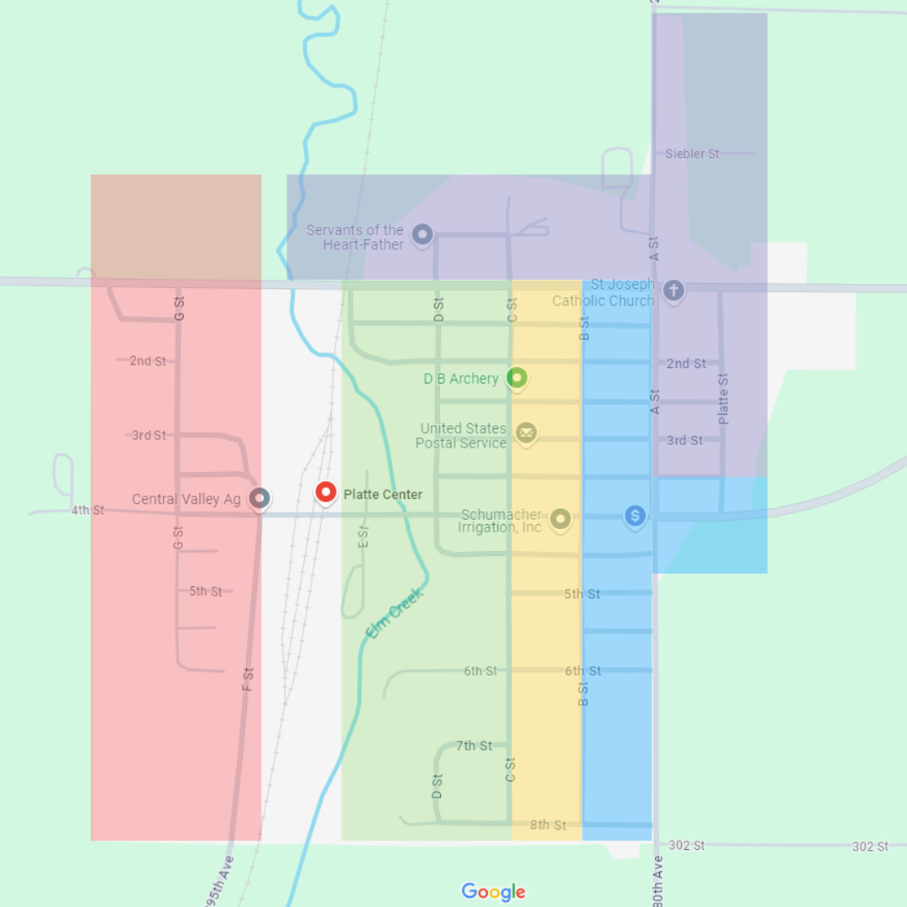

Town Cleanup Effort/5 Year Plan

Year 1- Purple- Ends September 30th, 2025

Year 2- Blue- Ends September 30th, 2026

Year 3- Yellow- Ends September 30th, 2027

Year 4- Green- Ends September 30th, 2028

Year 5- Red- Ends September 30th, 2029

Ordinances to be focused on:

133.02 **Appliances in Yard:** It shall be unlawful for any person to permit a refrigerator, icebox, freezer or any other dangerous appliance to be in the open and accessible to children whether on private or public property unless the person first removes all doors and makes the same reasonably safe

133.40 **ABANDONED AUTOMOBILES**

(A) for the purpose of this section, the following definitions shall apply unless the context clearly indicates or requires a different meaning.

**ABANONDED VEHICLE**

1. A motor vehicle is an ABANDONED VEHICLE:
2. If left unattended, with no license plates or valid In Transit stickers issued pursuant to the motor vehicle registration act affixed thereto, for more than 6 hours in any public property;
3. If left unattended for more than 24 hours on any public property, except a portion thereof on which parking is legally permitted;
4. If left unattended for more than 48 hours, after the parking of such vehicle has become illegal, if left on a portion of any public property on which parking is legally permitted;
5. If left unattended for more than 7 days on private property if left initially without permission of he owner, or after permission of the owner is terminate;
6. ‘not applicable’
7. ‘not applicable’
8. A all-terrain vehicle or minibike is an ABANDONED VEHICLE:
9. If left unattended for more than 24 hours on any public property, except a portion thereof on which parking is legally permitted;
10. If left unattended for more than 48 hours, after the parking of such vehicle has become illegal, if left on a portion of any public property on which parking is legally permitted
11. ‘not applicable’
12. ‘not applicable’
13. ‘not applicable’
14. A **MOBILE HOME** is an abandoned vehicle if left in place on private property for more than 30 days after a local governmental unit, pursuant to an ordinance or resolution, has sent a certified letter to each of the last-registered owners and posted a notice on the mobile home, stating that the mobile home is subject to sale or auction or vesting of title as set forth in Nb. RS 60-1903
15. ‘not applicable’

(B) If an abandoned vehicle, at the time of abandonment, has no license plates of the current year or valid In Transit stickers issued pursuant to Neb. RS 60-376 affixed and is of a wholesale value, taking into consideration the consideration of the vehicle , of $250 or less, title shall immediately vest in the village. Any certificate of title issued under this division to the village shall be issued at no cost to the village

‘not necessary for notice’

133.41 **UNLICENSED OR INOPERABLE VEHICLES**

(A) No person in charge or control of any property within the village, other than village property, whether as the owner, tenant, occupant, or lessee, or otherwise, shall allow any partially dismantled, inoperable, wrecked, junked, or discarded vehicle to remain on that property longer than 30 days.

(B) No unlicensed vehicle shall be permitted to remain on any private or public property for any length of time, provided that this section shall not apply to the following:

(1) A vehicle bearing a calid “In Transit” sticker;

(2) A vehicle in an enclosed building;

(3) A vehicle on the premises of a business enterprise operated in a lawful place and manner when the vehicle is necessary to the lawful operation of the business: or

(4) A vehicle in an appropriate storage place or depository maintained in a lawful place and manner by the village.

(C) Any vehicle allowed to remain on property in violation of this section shall constitute a nuisance and shall be abated, and an person violating this section shall by guilty of an offense/

Penalty. See 10.99

150. 35 **UNSAFE BUILDINGS**

(A) For the purpose of this subchapter, the following definition shall apply unless the context clearly indicates or requires a different meaning/

UNSAFE BUILDING. Includes any building, shed, fence, or other human-made structure;

1. Which is dangerous to the public health because of its condition and which may cause or aid in the spread of disease or injury to the health of the occupants of it or neighboring structures;
2. (b) which because of faulty construction, age, lack of proper repair, or any other cause is especially liable to fire and constitutes or creates a fire hazards; or
3. Which by reason of faulty construction or any other cause is liable to cause injury or damage by the collapse or fall of all or any part of the structure.

(B) any such unsafe building in the village is hereby declared to be a nuisance. Penalty see 20.99

150.36 **PROHIBITIONS**

It shall be unlawful to maintain or permit the existence of any unsafe building in the village, and it shall be unlawful for the owner, occupant, or person ni custody of any dangerous building to permit the same to remain in an unsafe condition or to occupy the building or permit it to be occupied while it is in an unsafe condition.

Penalty, see 10.99

91.24 **WEEDS; LITTER; STAGNANT WATER**

(A) ‘not applicable’

(B) The owner of occupant of any lot or piece of ground within the village or within its extraterritorial zoning jurisdiction shall keep the lot of piece of ground and the adjoining streets and alleys free to any growth of 12 inches or more in height of weeds, grasses, or worthless vegetation.

(C)The throwing, depositing, or accumulation of litter on any lot or piece of ground within the village or within it’s one mile-zoning jurisdiction is prohibited.

(D) It is hereby declared to be a nuisance to permit or maintain any growth of 12 inches or more in high of weeds, grasses, or worthless vegetation on any lot of piece of ground within the village or within its one-mile zoning jurisdiction or on the adjoining streets or alleys or to litter or cause litter to be deposited or remain thereon except in property receptacles.

**LITTER**. Includes but is not limited to:

1. Trash, rubbish, refuse, garbage, paper, rags, and ashes;
2. Wood, plaster, cement, brick, or stone building rubble;
3. Grass, leaves, and worthless vegetation except when used as ground mulch ir in an compost pile;
4. Dead animals; and
5. Any machine or machines, vehicle, or vehicles, or parts of a machine or vehicle which have lost their identity, character, utility, or serviceability as such through deterioration, dismantling, or the ravages of time, are inoperative or unable to perform their intended functions, or are cast off, discarded, or thrown away or left as waste, wreckage, or junk.