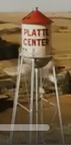
Village of
Platte Center, NE

REQUEST FOR FUTURE
AGENDA ITEM

If you have a specific topic that you would like the Board of Trustees to discuss at a future meeting, please list your name, address, email, telephone number, and the specific topic. The item will be reviewed and possibly scheduled for a future meeting, or forwarded to Village staff for appropriate action. Regular Board meetings are held on the second Tuesday of the month. Agenda items to be considered must be submitted by the Friday before the intended meeting.

Name:
Address:

Email:
Telephone #:
Date of Request:
Description of Requested Topic:

Meeting Date:

